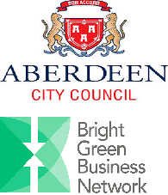
The Benefits of Sustainable Transport for your Business

Date: Friday 21st November
Time: 12:30-3pm
Venue: Marischal College, Gallowgate, Aberdeen City, AB10 1YS.
Cost: £10 Members/ £15 Non-members
The Bright Green Business Network is delighted to bring to your attention a Sustainable Transport event to be held in partnership with Aberdeen City Council at the Marischal College in Aberdeen. The event will commence with a buffet lunch giving you an opportunity to network with potential contacts.
Bright Green Business will discuss how we can support businesses to identify sustainable transport and implement measures to manage their impact. We will hear from an expert panel of speakers some of which include, Tony Archer from Co-wheels Car Club, Fiona Goodenough from Aberdeen City Council and Abigail Betney from Energy Saving Trust, on differing sustainable transport options and what the benefits of utilising these would be for your business. Such topics will include formulating travel plans, looking at alternative travel, changing behaviour and measuring your business’ footprint.
Sign up today to secure your place at this event. It is not to be missed!
To book your place, visit the website or call 0131 603 5048.

